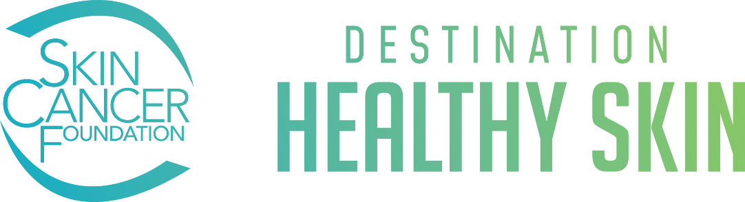

Frequently Asked Questions

What is Destination Healthy Skin?
Destination Healthy Skin is The Skin Cancer Foundation’s mobile skin cancer screening and education program. Our 38-foot RV is equipped with two private exam rooms where volunteer dermatology providers perform free screenings. In our waiting area, program managers answer questions and distribute skin cancer early detection and prevention information.

Each year, we travel to dozens of communities around the country, screening about 2,000 people and educating thousands more. Check our schedule to see where we will be this year.

How much does it cost?
Destination Healthy Skin is a public service program. No health insurance is necessary, and screenings are free of charge. Furthermore, you will receive free skin cancer educational materials and sun protection products.

Do I have to make an appointment in advance?
We do not take appointments; dermatology providers perform skin cancer screenings on a first-come, first-served basis and subject to provider availability. We recommend arriving early if possible.

What should I expect during my skin exam?
Skin cancer screenings take place in our Destination Healthy Skin RV, which is equipped with two private exam rooms. You’ll be given a brief form to fill out while you wait for your turn. Then you’ll be shown into an exam room and provided with a gown. When you’re ready, the provider will come into the room and examine your skin from head-to-toe. They will note the findings on your form and make recommendations for next steps. The exam itself takes approximately ten minutes.

The provider recommended I get a biopsy. Now what should I do?
If a biopsy is recommended, you can ask the provider if they are accepting new patients and can take your insurance.

If you need to find another medical professional, use the following resources to find one near you:

Skin Cancer Foundation Find a Dermatologist
American Academy of Dermatology Find a Dermatologist

For help finding affordable or no-cost treatment, check our Treatment Assistance resources.
Learn more about the biopsy process: You Need a Biopsy: Now What Happens?
When are you coming to my city?
We wish we could come to every city that will have us each year! We do the best we can with the resources we have. Locations are carefully selected based on driving times, weather patterns and volunteer provider interest. If we do not stop at your location this year, we may be coming next year.

Why can’t the RV be on the road year-round?
Driving, fueling, maintaining and staffing our RV with program managers gets quite expensive. Even with the support of individuals and corporate partners, we would need to raise four times the funds to keep Destination Healthy Skin on the road all year. You can help by making a donation.

Is the RV wheelchair accessible?
Yes! The Destination Healthy Skin RV is equipped with a wheelchair lift to access the exam rooms for a skin cancer screening.

I love this program and want to support it.
Thank you! This lifesaving journey would not be possible without the support of wonderful donors like you. If you would like to keep Destination Healthy Skin on the road this year and beyond, here is how you can help:

- Make a Donation to support the program financially.
- Create a Fundraiser to make a bigger impact and encourage people to donate.
- Share on social media using our toolkit to spread the word about Destination Healthy Skin

I am a dermatology provider and want to volunteer, what should I do?
People around the country are eagerly awaiting the arrival of our RV, but we still need volunteers. Check our schedule to see if you can lend a hand.

How you can help:
- Please volunteer your time to perform screenings and join the Foundation’s efforts to save and improve lives. To sign up, please email avenosa@skincancer.org or click here. Shifts are typically 10 AM to 1 PM or 1 PM to 4 PM but we can be flexible to fit your schedule. Please be sure to provide your city and state. If we are not coming to your area this year, we may be next year. It helps to have potential volunteers on file.
- Share with your network: If you cannot participate this year, please send our volunteer page to your colleagues who may be able to help! Our custom, air-conditioned RV is equipped with two private exam rooms to provide a safe, high-quality experience.

I am a physician assistant or nurse practitioner. Can I volunteer to help?
Yes! Qualified dermatology PA-Cs and NPs can volunteer to perform screenings at Destination Healthy Skin events. For more information about volunteer requirements, please contact Ali Venosa at avenosa@skincancer.org.

Where can I find more information about Destination Healthy Skin?
Learn more about Destination Healthy Skin on our website.
Check our blog for stories about past events.
Can I share information about Destination Healthy Skin on social media?
Yes! You can share images and content from our social media toolkit, website and social media platforms. Since our information is copyrighted, please follow these guidelines when sharing:
- Do not modify images, graphics or content in any way. Do not add your logo or watermark.
- Remember to cite The Skin Cancer Foundation as the source.
- Be sure to tag us @SkinCancerFoundation on Facebook and LinkedIn, and @SkinCancerOrg on Instagram, Threads, Pinterest, X and TikTok.

